Lab 2
Implementing HSRP and VRRP
Objective:
The purpose of this lab is for the student to understand and implement HSRP and VRRP. Students will also utilize IOS commands to explore and configure HSRP and VRRP between routers.
Diagram:
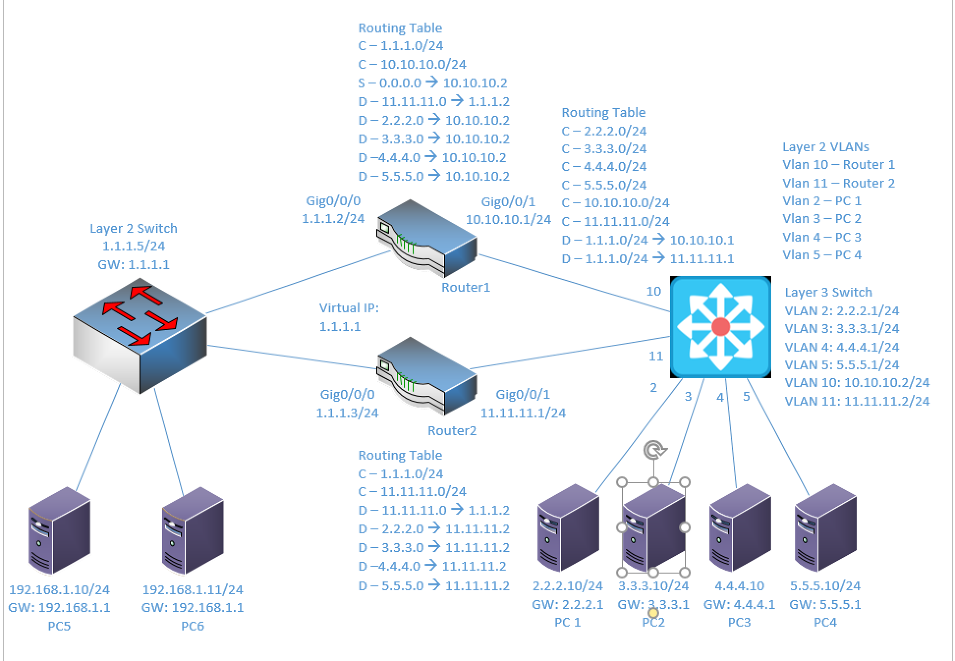
Components:
6 – PC’s
1 – Cisco 3650 Layer 3 Switch
1 – Cisco 3650 Layer 2 Switch
2 – 2 Port Cisco 4321 Routers

Useful commands for this lab:
show ip route – view routing table
show vlan – View vlan table and port assignments
show ip interface brief – view status of layer 3 ports
show standby brief – view hsrp configuration and stats
show vrrp brief – view hsrp configuration and stats

Enable routing on Layer 3 switch
ip routing

Enable HSRP on Active Router:
interface gigabitethernet0/0/1
ip address 1.1.1.2 255.255.255.0
standby 10 ip 1.1.1.1
standby 10 preempt
standby 10 priority 200
no shutdown

Enable HSRP on Standby Router:
interface gigabitethernet0/0/1
ip address 1.1.1.3 255.255.255.0
standby 10 ip 1.1.1.1
standby 10 preempt
standby 10 priority 50
no shutdown

Enable VRRP on Active Router:
interface gigabitethernet0/0/1
ip address 1.1.1.2 255.255.255.0
vrrp 10 ip 1.1.1.1
vrrp 10 preempt
vrrp 10 priority 200
no shutdown

Enable VRRP on Standby Router:
interface gigabitethernet0/0/1
ip address 1.1.1.3 255.255.255.0
vrrp 10 ip 1.1.1.1
vrrp 10 preempt
vrrp 10 priority 50
no shutdown

Enable EIGRP:
router eigrp 5
network 1.1.1.0 0.0.0.255
network 10.10.10.0 0.0.0.255
no auto-summary

Procedure:
- Connect all PC’s together on the layer 3 switch and put their static IP addresses, subnet masks and gateways on them. Test connectivity by pinging each machine within the network.

- Use the Diagram to label the Layer 3 switches VLAN IP addresses and ports below
Layer 3 Switch VLAN
VLAN | IP | Ports
2 | 2.2.2.1/24 | 2
3 | 3.3.3.1/24 | 3
4 | 4.4.4.1/24 | 4
5 | 5.5.5.1/24 | 5
10 | 10.10.10.1/24 | 10
11 | 11.11.11.1/24 | 11

- Use the Diagram to label the routing tables for the Layer 3 switch and routers below.
Router 1 | Router 2 | Layer 3 Switch
C – 1.1.1.0/24 | C - 1.1.1.0/24 | C - 2.2.2.0/24
C – 10.10.10.0/24 | C - 11.11.11.0/24 | C - 3.3.3.0/24
S - 0.0.0.0 -> 10.10.10.2 | D - 11.11.11.0 -> 1.1.1.2 | C - 4.4.4.0/24
D - 11.11.11.0 -> 1.1.1.2 | D - 2.2.2.0 -> 11.11.11.2 | C - 5.5.5.0/24
D - 2.2.2.0 -> 10.10.10.2 | D - 3.3.3.0 -> 11.11.11.2 | C - 10.10.10.0/24
D - 3.3.3.0 -> 10.10.10.2 | D - 4.4.4.0 -> 11.11.11.2 | C - 11.11.11.0/24
D - 4.4.4.0 -> 10.10.10.2 | D - 5.5.5.0 -> 11.11.11.2 | D - 1.1.1.0/24 -> 10.10.10.1
D - 5.5.5.0 -> 10.10.10.2 | C - 11.11.11.0/24 | D - 1.1.1.0/24 -> 11.11.11.1

- Place the switch ports into the proper vlans. Configure all of the switches vlan IP addresses.

- Enable routing on the Layer 3 switch. You do not, and should not, enable routing on the device being used as a Layer 2.

- View the routing table on the Layer 3 switch. You should have a connected route for all VLANs configured on the switch.

- Verify that the PCs on the switch can ping each other

- Configure the IP addresses on both of the routers interfaces and turn the interfaces on.

- Enable EIGRP on the Layer 3 switch and both routers. Remember: you need a network command for each network on the device. For Instance: Router 1 would get “network 1.1.1.0 0.0.0.255” and “network 10.10.10.0 0.0.0.255”.

- Have PC’s 1.1.1.10 and 1.1.1.11 ping both routers interface IP’s (1.1.1.2 and 1.1.1.3)
  - Are the pings successful? No
  - Why? There is no gateway set up

- Have PC’s 1.1.1.10 and 1.1.1.11 ping 1.1.1.1. Remember, some tests will be unsuccessful since the configuration isn’t complete.
  - Are the pings successful? No
  - Why? We have not configured this IP address yet in HSRP

- On the first router, add a HSRP IP of 1.1.1.1, set a priority of 200, enable preempt and use a group number of 1

  - What commands did you enter?
standby 1 ip 1.1.1.1
standby 1 preempt
standby 1 priority 200

- On the second router, add a HSRP IP of 1.1.1.1, set a priority of 100, enable preempt and use a group number of 1

  - What commands did you enter?
standby 1 ip 1.1.1.1
standby 1 preempt
standby 1 priority 100

- Have PC’s 1.1.1.10 and 1.1.1.11 ping 1.1.1.1
  - Are the pings successful? Yes
  - Why? HSRP is set up on the router

- Have PC’s 1.1.1.10 and 1.1.1.11 ping 3.3.3.10
  - Are the pings successful? Yes
  - Why? HSRP is acting as a gateway on the router and EIGRP has been configured so the ping is routed correctly

- Start a continuous ping from 1.1.1.10 to 2.2.2.10

- Remove the Ethernet cables from the first router.
  - What happened? A couple of pings were lost, then the connection resumed
  - Why? HSRP configured on the second router took over after a few seconds

- Put the Ethernet cables back into the first router.
  - What happened? Again, we lost some pings, then they resumed
  - Why? The priority of the routers is different, so the network took a few seconds to return to the original distribution

- Remove the Ethernet cables from the second router.
  - What happened? The pings continued without interruption
  - Why? Router 1 has a higher priority and remained connected, so the pings never stopped going through

- Put the Ethernet cables back into the second router.
  - What happened? Nothing
  - Why? Router 2’s lower priority meant that it never took over or was the primary router, so there was no interruption in service

- On the first router, remove the HSRP commands previously entered.
  - What commands did you enter?
no standby 1 ip 1.1.1.1
no standby 1 preempt
no standby 1 priority 200

- On the second router, remove the HSRP commands previously entered.
  - What commands did you enter?
no standby 1 ip 1.1.1.1
no standby 1 preempt
no standby 1 priority 100

- Have PC’s 1.1.1.10 and 1.1.1.11 ping 1.1.1.1
  - Are the pings successful? No
  - Why? There is no longer a virtual IP of 1.1.1.1 set up via HSRP

- On the first router, add a VRRP IP of 1.1.1.1, set a priority of 200, enable preempt and use a group number of 1

  - What commands did you enter?
vrrp 1 ip 1.1.1.1
vrrp 1 preempt
vrrp 1 priority 200

- On the second router, add a VRRP IP of 1.1.1.1, set a priority of 100, enable preempt and use a group number of 1

  - What commands did you enter?
vrrp 1 ip 1.1.1.1
vrrp 1 preempt
vrrp 1 priority 100

- Have PC’s 1.1.1.10 and 1.1.1.11 ping 1.1.1.1
  - Are the pings successful? Yes
  - Why? VRRP is set up with the 1.1.1.1 IP

- Have PC’s 1.1.1.10 and 1.1.1.11 ping 3.3.3.10
  - Are the pings successful? Yes
  - Why? EIGRP is still set up on the routers, so the pings are routed correctly

- Start a continuous ping from 1.1.1.10 to 2.2.2.10

- Remove the Ethernet cables from the first router.
  - What happened? The pings paused for a few seconds then resumed
  - Why? The primary router went down, so the network took a couple seconds to go to the standby router

- Put the Ethernet cables back into the first router.
  - What happened? A few pings were lost, then they resumed
  - Why? When the primary router went back up, it took the network a few seconds to reconfigure back to its original state

- Remove the Ethernet cables from the second router.
  - What happened? Nothing
  - Why? As the standby router, it never routed the traffic in the first place, so disconnecting it didn’t affect the pings

- Put the Ethernet cables back into the second router.
  - What happened? Again, nothing
  - Why? As long as router 1 is connected and functioning as the primary router, router 2’s effect on the network is practically nonexistent.

- On the first router, remove the VRRP commands previously entered.
  - What commands did you enter?
no vrrp 1 ip 1.1.1.1
no vrrp 1 preempt
no vrrp 1 priority 200

- On the second router, remove the VRRP commands previously entered.
  - What commands did you enter?
no vrrp 1 ip 1.1.1.1
no vrrp 1 preempt
no vrrp 1 priority 100

- Have PC’s 1.1.1.10 and 1.1.1.11 ping 1.1.1.1
  - Are the pings successful? No
  - Why? VRRP is not there anymore so 1.1.1.1 isn’t tied to anything.

- Is there a difference in operation between HSRP and VRRP? Meaning, do they behave the same even though they’re configured with different commands?
Practically speaking, no there isn’t really a difference between HSRP and VRRP other than HSRP being Cisco proprietary and VRRP being the open standard. They behave the same.

- Create the lab diagram below (PCs, router and switch connections) in Packet Tracer or Visio. Label the IP addresses, subnet masks, and gateways used by each device. Label the routing tables next to the switch and router and the switches vlan IP addresses and port vlan information. Label the virtual IP address shared between the routers.

